* Purpose : Classwork
* Date : 19/12/2025
* Author : Vikas Srivastava
* ID : 55984
* Batch ID : 25SUB4505
--------------------------------------------------------------------------------------------------------------------------
- Code : Write a program to display the message “Hello World!” on the screen using the C programming language.

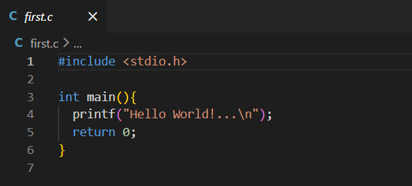
Output :

2. Code : Write a Program to checks whether a specific bit position in a number is ON (1) or OFF (0).
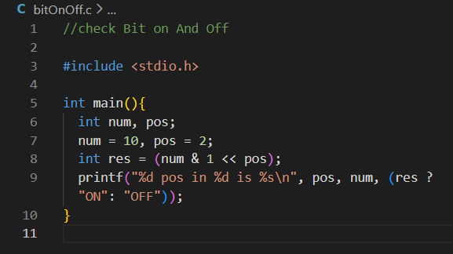
Output :
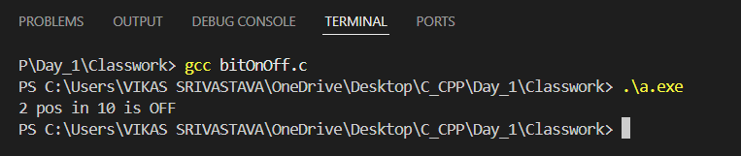

- Code : Write a Program to demonstrates implicit type conversion in C.
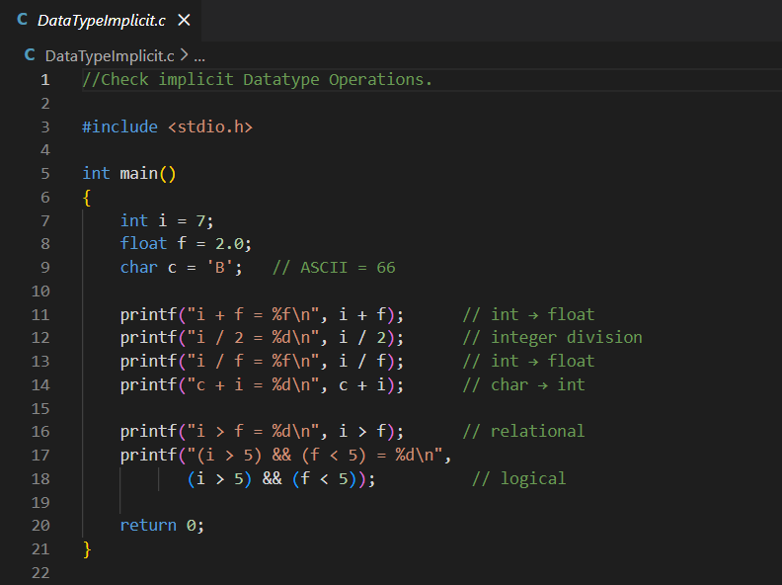
Output :
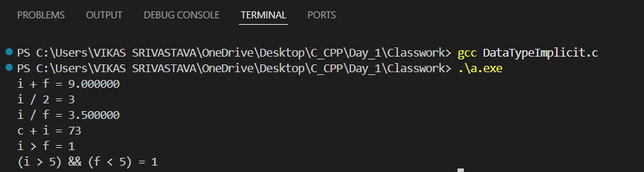

- Code : Write a Program to shows how the same binary value is interpreted differently when treated as signed and unsigned data types.
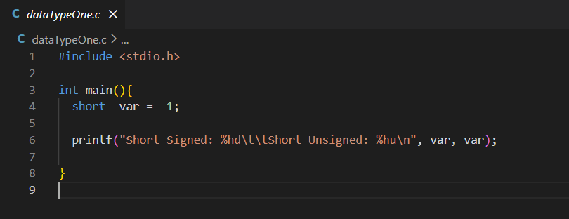
Output :
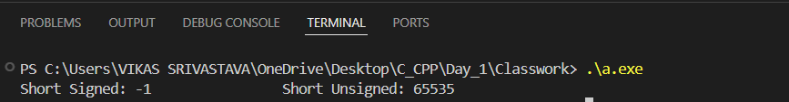

- Code : Write a program to demonstrate the working of a do-while loop by printing numbers from 0 to 10.
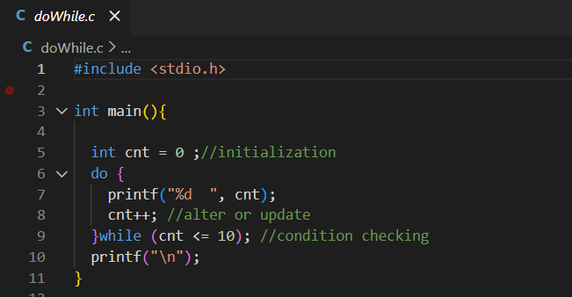
Output :
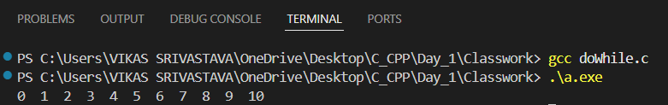

- Code : Write a program to demonstrate a menu-driven application using a do-while loop and switch-case, where the user selects an option and the program executes the corresponding choice until an invalid option is entered.

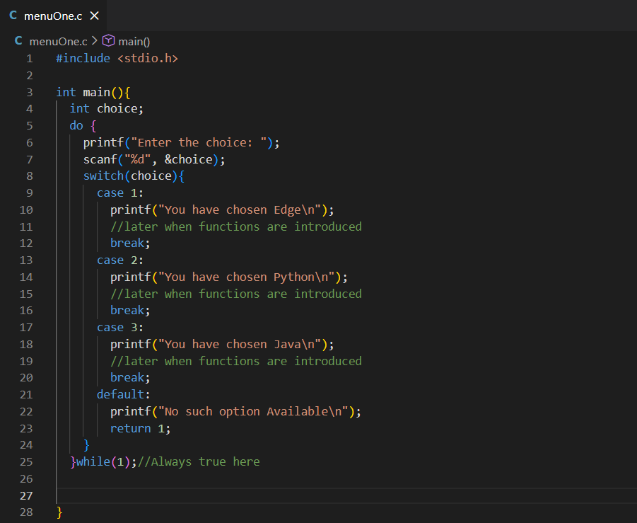

Output :
